**SEO Success**

This is Chicken and Grill multi-franchise food industries.

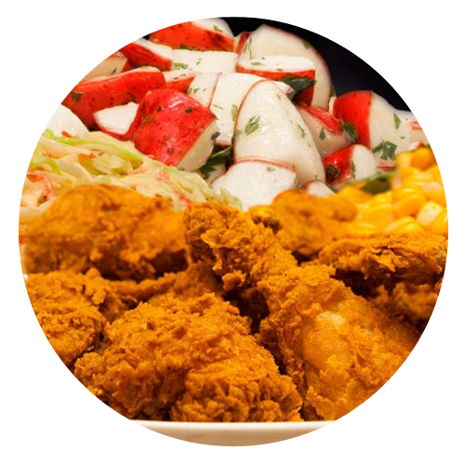

**By May 2019**

**Prior to SEO**

**Chicken and Grill multi-franchise food industries** came in June of 2018, with some online presence. They wanted to improve their local presence by increasing organic rankings and traffic to their website and increase clientele. At the time they signed on for our SEO services they had just 22 keywords ranking on the first page of major search engines.

**Dec-18**

**Increase in Website Pageviews. 140,122 Pageviews received in last 1 month.**

The momentum of the campaign was in full throttle as they now ranked on the first page of search engines for **130 keywords**. An increase of more than 54%.

90 days later, the website went from ranking for just 27 keywords on Page 1 of results to ranking for **50 keywords** on the first page. An increase of 46%.

**After 3 Months**

**After 6 Months**

90 days later, the website went from ranking for just 22 keywords on Page 1 of results to ranking for **27 keywords** on the first page. An increase of 23%.

**24.57%**

**18.68%**

**13.23%**

* We ensured that all name, address, and phone number information was correct, complete and consistent across key sites, including top tier directories such as **Google My Business** and **Bing Local**.
* We developed and distributed **SEO friendly content** on relevant websites.

**Increase in Google Organic Sessions. 44,040 Organic visits received in last 1 month.**

**Increase in Overall Website Traffic. 60,304 Overall visits received in last 1 month.**

**Google Analytics data**

*Major Search Engines defined as Google and Bing

**Sept-18**

**May-19**

**Keywords Ranking on First Page in Major Search Engines\***

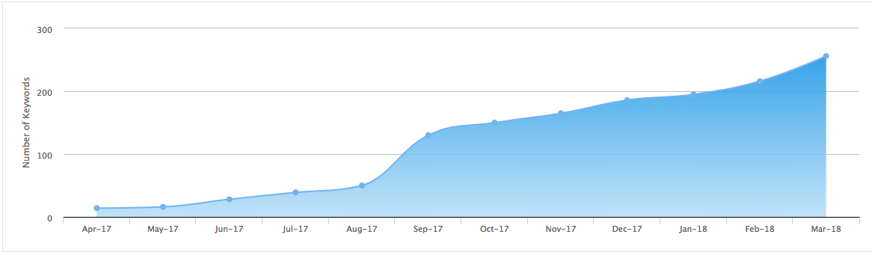

* We identified how potential customers were searching through extensive **keyword research**.
* We designed & implemented an SEO campaign that included **on-page** and **off-page optimization** around their targeted keyword terms.

**Our Approach**